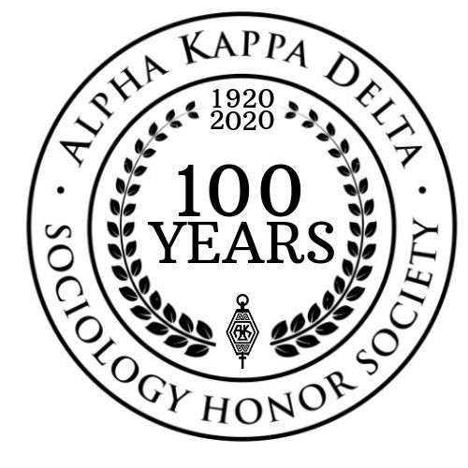

Alpha Kappa Delta Certificate Program in Teaching and Learning

The Alpha Kappa Delta Certificate Program in Teaching and Learning is designed to provide
participants with a rich learning experience that will help them build their teaching portfolios and
become more effective faculty in colleges and universities.

The program requires attendance at five sessions of the candidate’s choosing at any of the
AKD workshops offered throughout the year. In 2022-23, there are sessions being offered at the
annual meeting of the Mid-South Sociological Association, Eastern Sociological Society, Midwest Sociological Society, North Central Sociological Association, Pacific Sociological Association, Southwestern Social Science Association, and possible virtual stand-alone sessions in the summer 2023. See the attachments for details on dates, times, and topics.

Submission Deadline: August 31, 2023

For more information and an application form, visit: alphakappadelta.org or email
AKD@lemoyne.edu.

Attachment: 2022-23 sessions at regional sociological society annual meetings & stand-alone sessions

Sessions For Alpha Kappa Delta Certificate Program in Teaching and Learning

October 13 & 14, 2022: Embedded Sessions at the Mid-South Sociological Association annual meeting (hybrid)
- Thursday, October 13, 12:30-1:30pm: AKD Mentoring Session
- Friday, October 14, 12:30-1:30pm: AKD Mentoring Session

June 22, 2022, 1:00pm-3:00pm ET: Publishing Your Work (virtual)

February 23, 2023, 12:00pm-5:00pm: Session at the Eastern Sociological Society annual conference, “Emerging Stronger” (in-person)

March 23, 2023, 1:00pm-5:00pm: AKD Pre-Conference at the North Central Sociological Association annual conference (in-person) “All Together Now: Transforming Group Projects & Collaborative Learning Strategies”

March 23, 2023, 11:15am-12:45pm: Graduate Student Teaching Workshop at the Midwest Sociological Society annual conference (in-person)
March 24, 2023, 2:45pm-4:15pm: Session at the Midwest Sociological Society annual conference (in-person) "Different Instructors, Same Course"
March 31, 2023, 8:30-11:15am: Workshop at the Southwestern Social Science Association annual conference (in-person) "Learning From Each Other"
March 30-April 2, 2023: Embedded Sessions at the Pacific Sociological Association Annual Conference
- March 30, 2023, 2:15pm-3:45pm: "Inclusive Designs: Pedagogical and Curricular Approaches"
- April 1, 2023, 10:45am-12:15pm: "Pathways to Mentoring, Training, and Research"
- April 1, 2023, 10:45am-12:15pm: "Getting Jobs in Academia"
- April 2, 2023, 10:45am-12:15pm: "Transformative Learning and Pedagogy Across Contexts"

AKD Teaching and Learning Certification Application

Your name:

 | Title of session attended | Day/Time of session | Facilitator | Location (virtual or f2f, embedded in a regional association program or AKD stand-alone workshop)
1.
2.
3.
4.
5.
extra

Submit this form as well as a statement for how you will incorporate material from each of these sessions into your teaching. The statement should be no more than 1000 words (approximately 200 words per workshop session). Include any handouts provided by the facilitator and copies of emails from the facilitator or workshop organizer confirming your participation.

Applications will be reviewed by a panel that includes members of the AKD Council.

Deadline: 8/31/2023 (send to Bethany Titus, Executive Director, AKD@lemoyne.edu)

